


Guy asked himself: how are chips discoverd? Paprica or bolongnaise, ribs or cirkels.
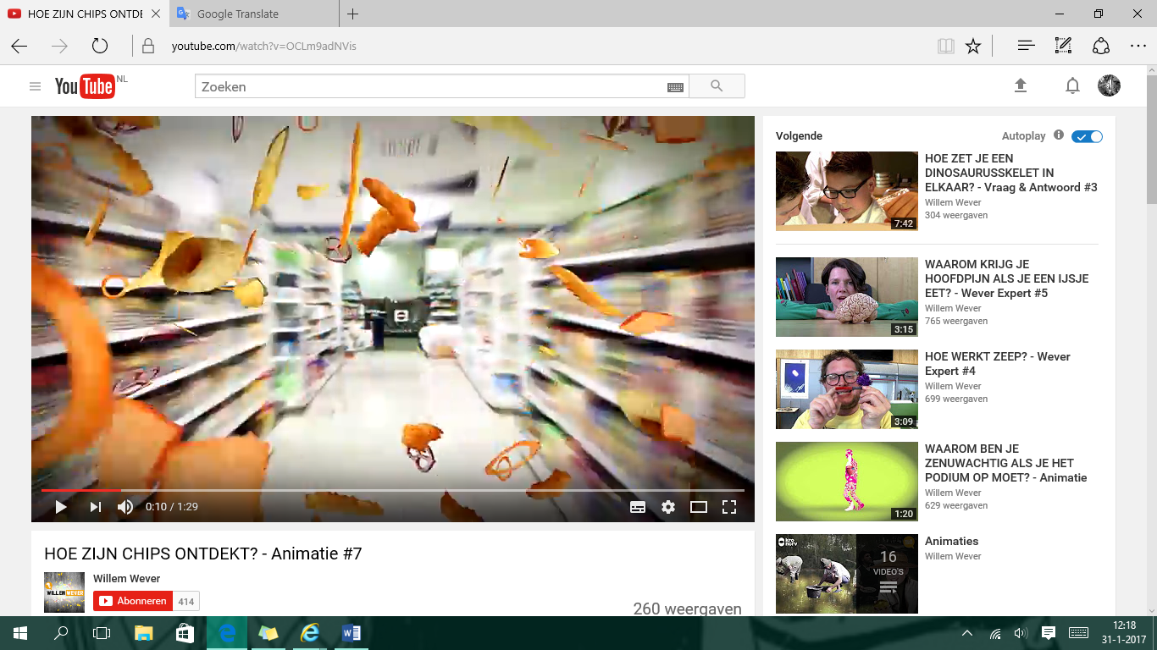
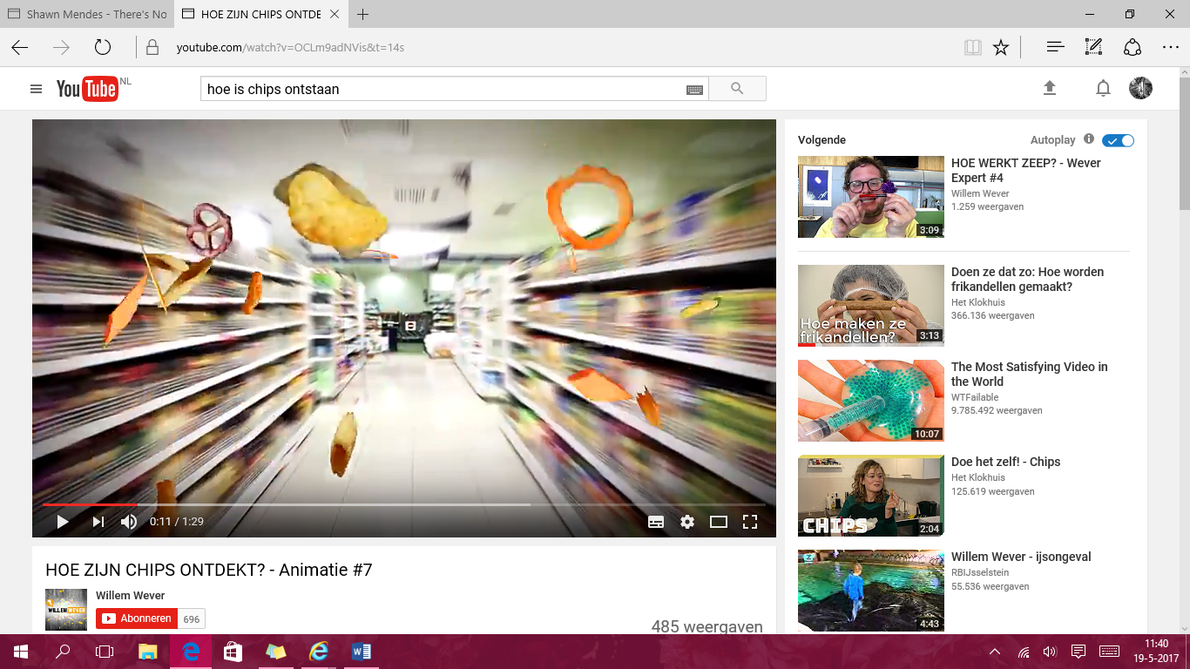

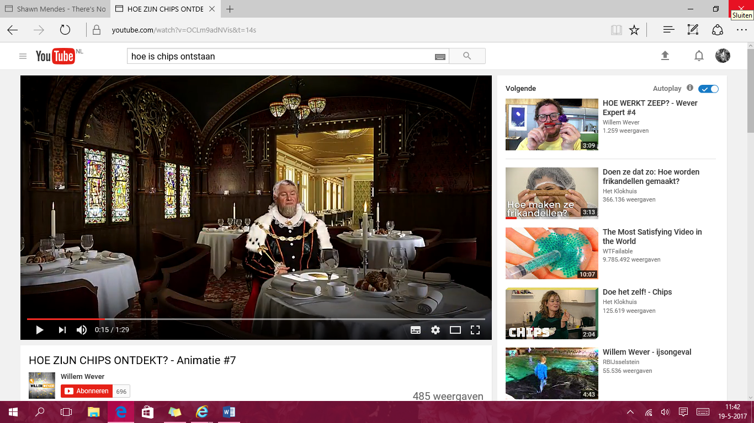
We have a lot of spieces in the supermarket. And than it is sometimes difficult to choose
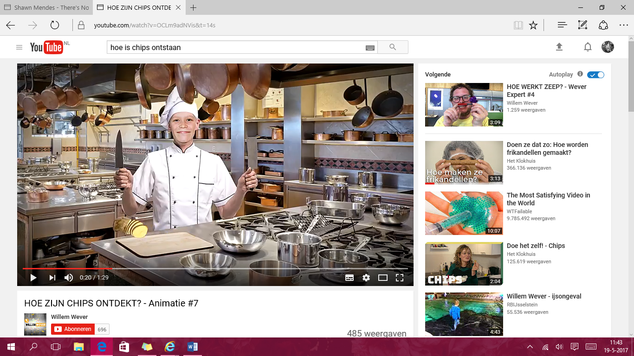

160 years ago was there a cook they invented A customer mopped about his to thick potato by mistake. slices and sent his plate back to the kitchen.

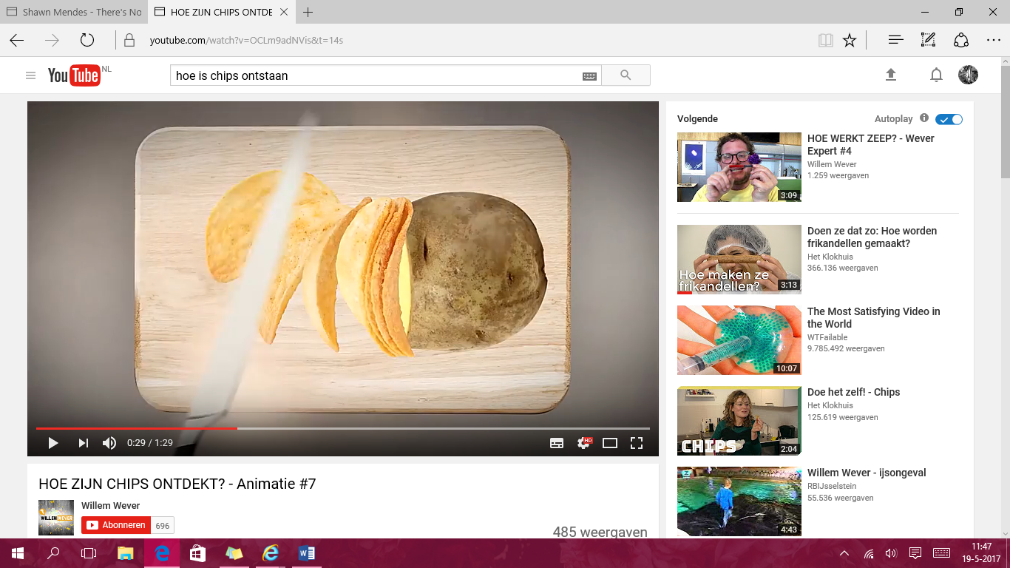
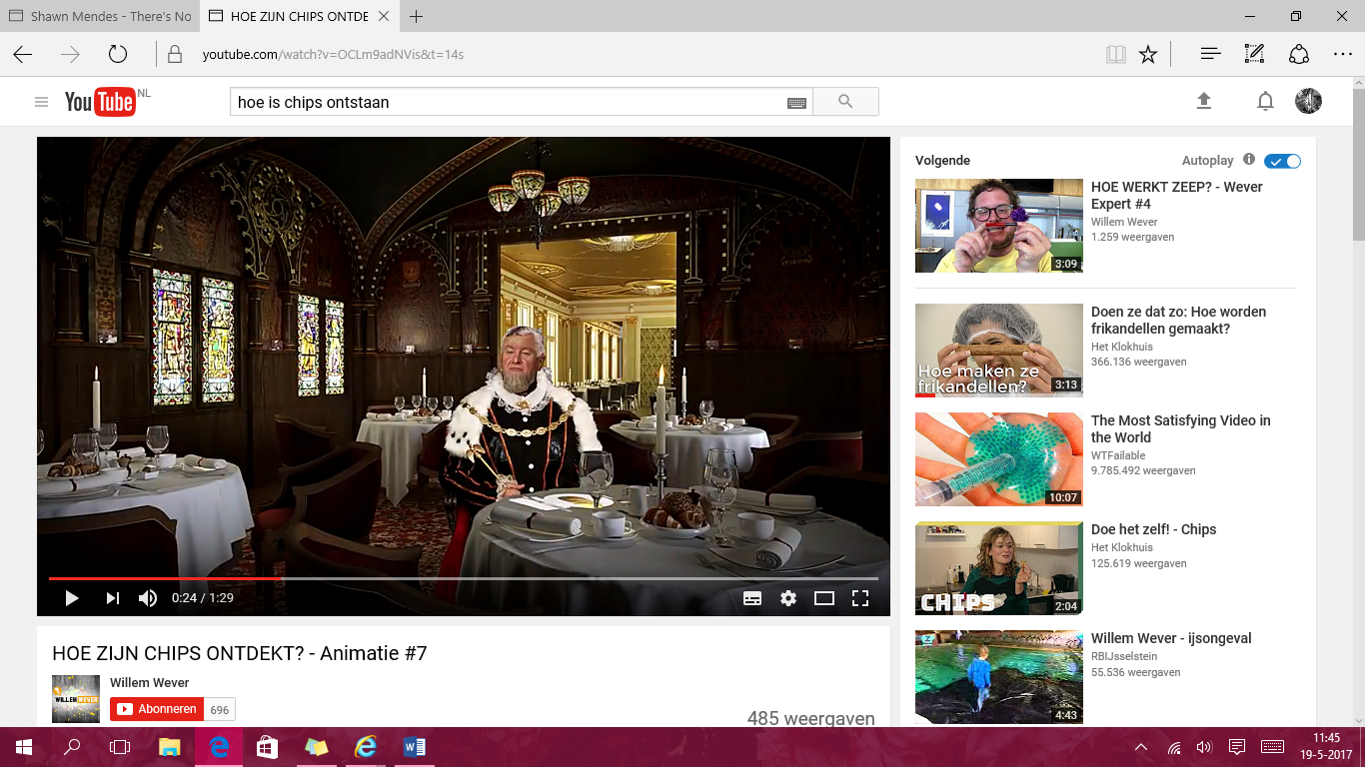

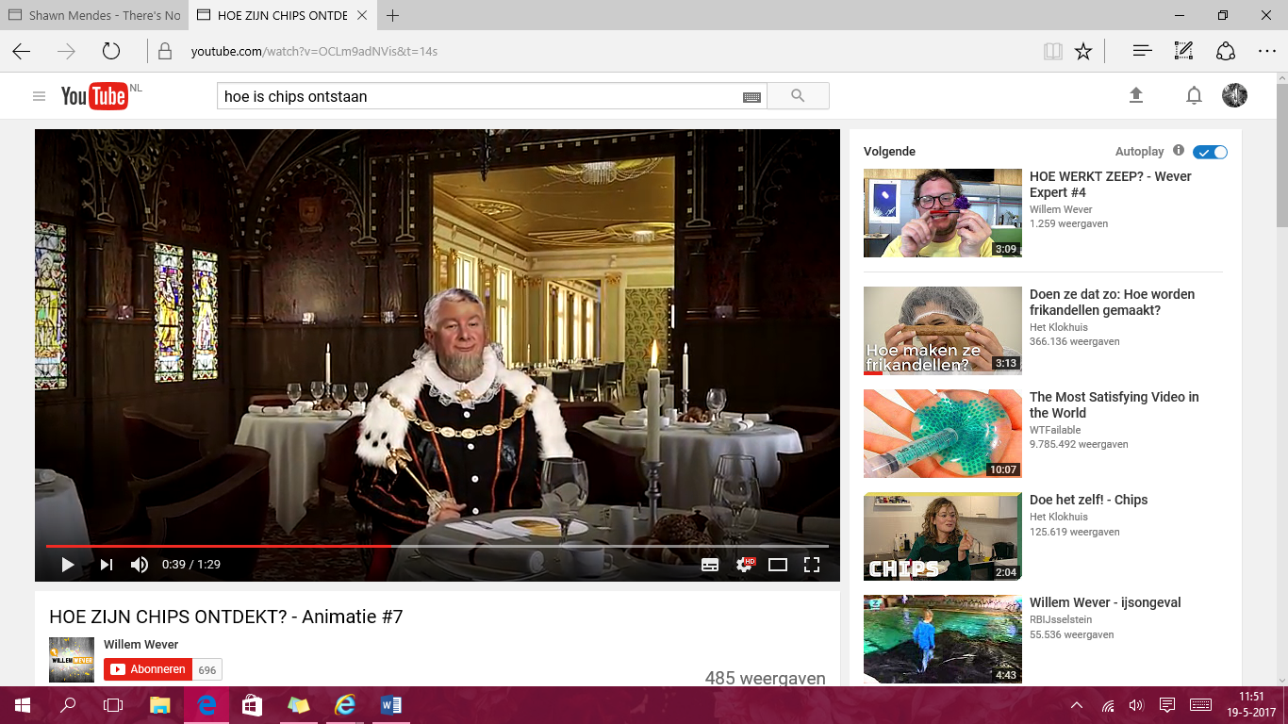
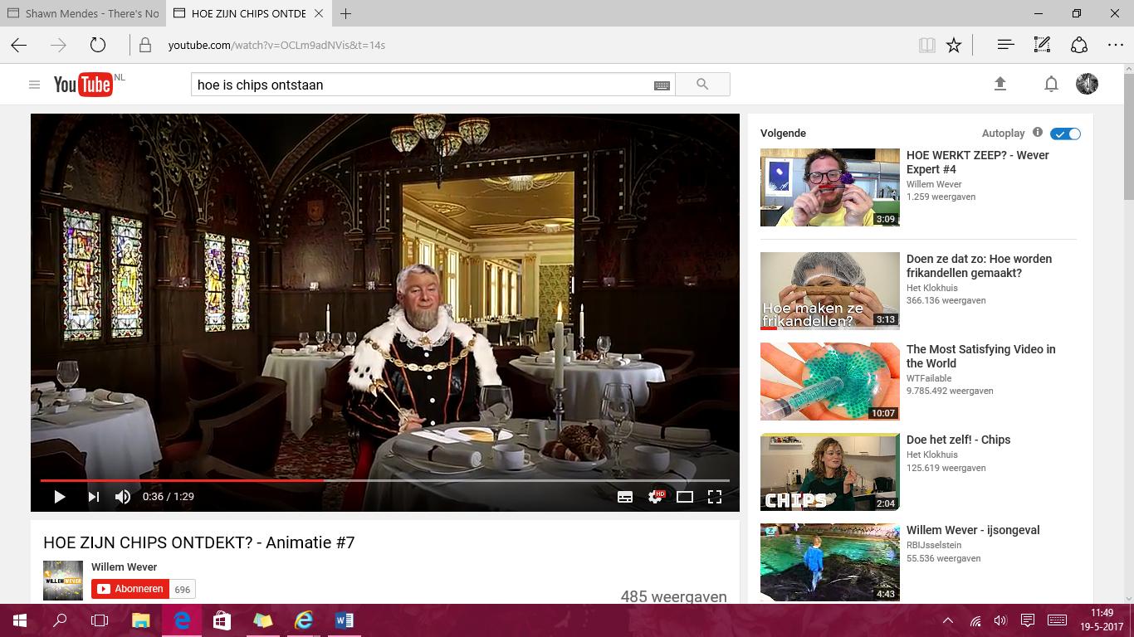
To cook slices the slices thinner slices but that The cook lost his patience and cut the potato was still not good enough for the customer. into super thin slices he tought to bully the customer.

The cook lost his patience and cut the potato But to his surprise he was not angry but into super thin slices he tought to bully the very enthusiastic about his flatter thin customer. Baked potato slices.
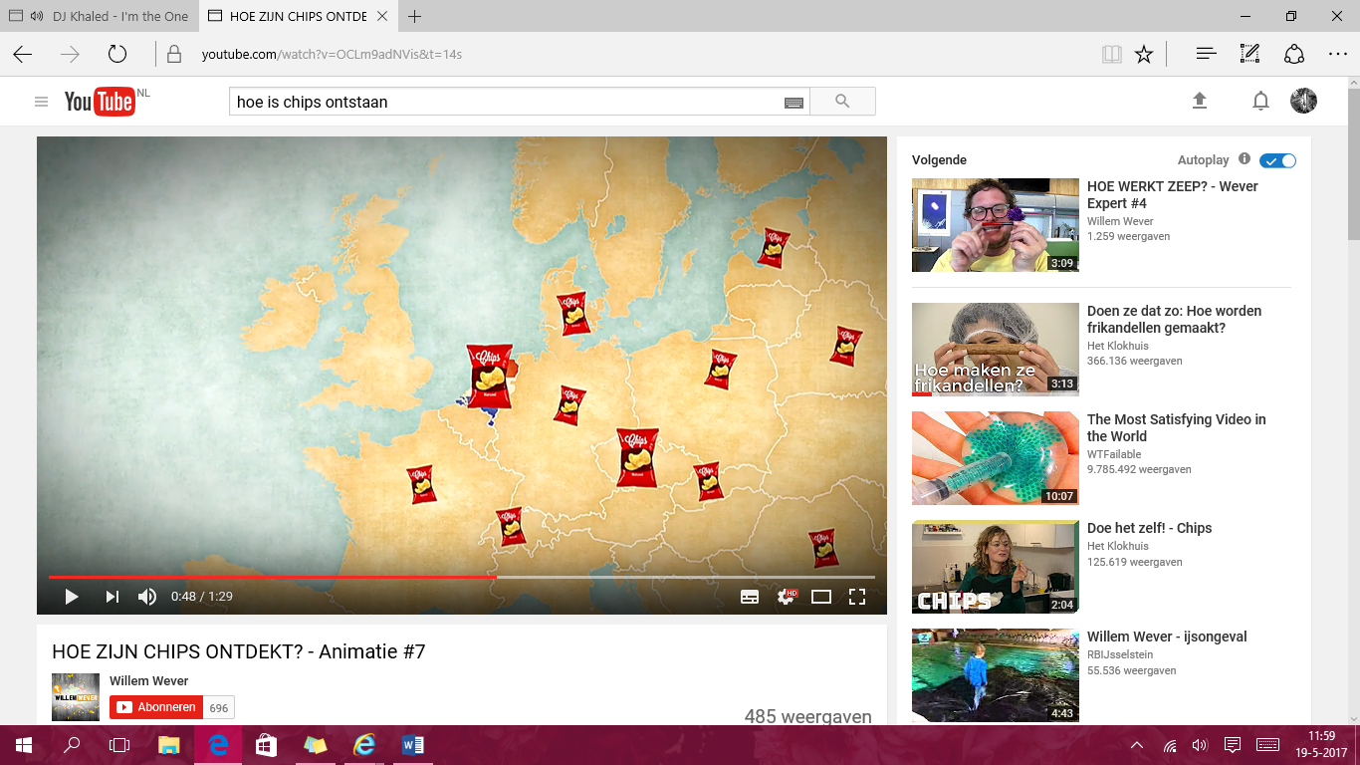
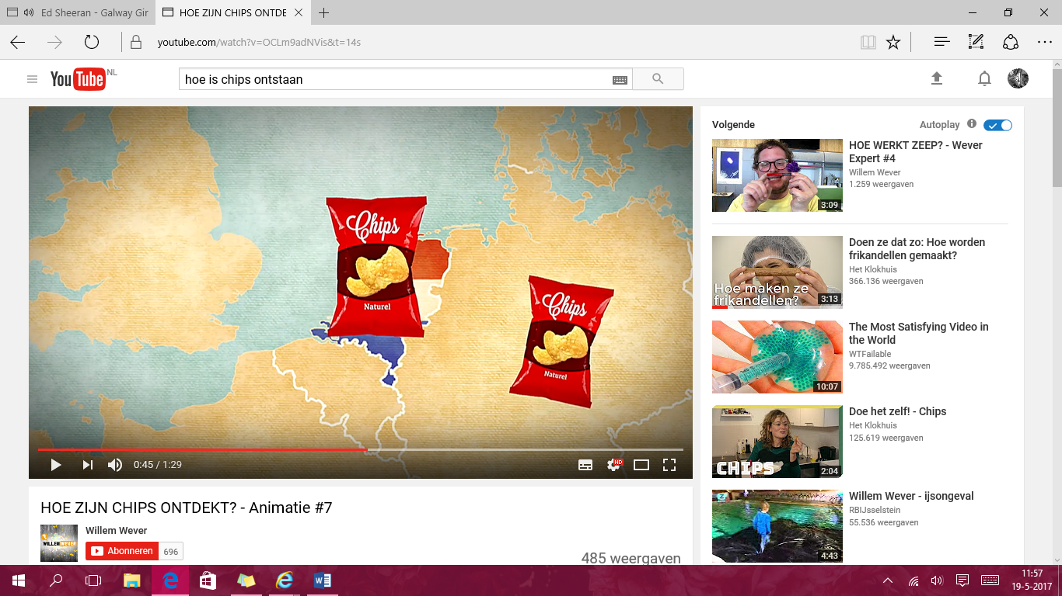

Tghe chips were so nice that they soon went all in the netherlands we could eat chips from the
Over the world. 50’s

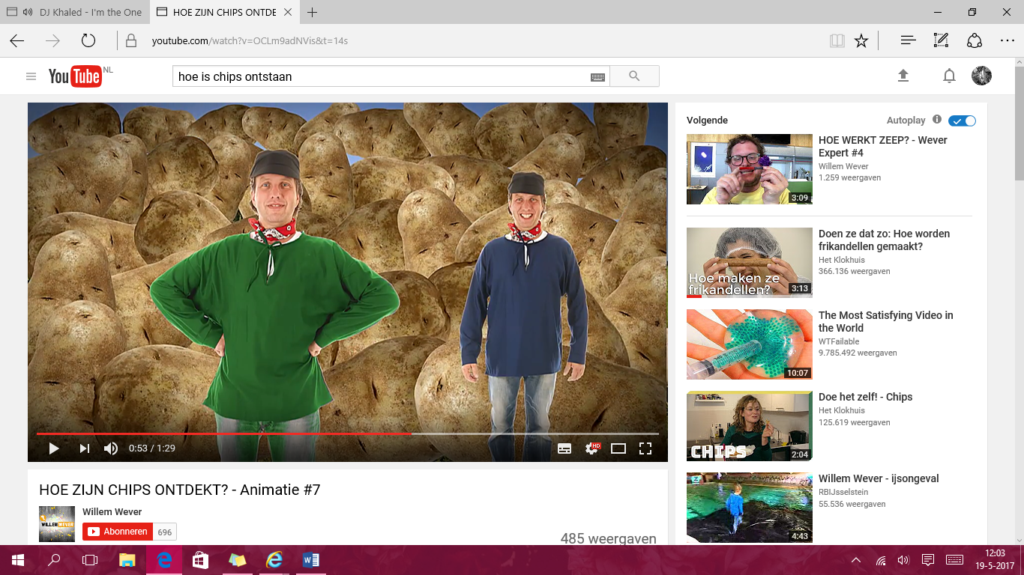


A group of potato famers wished to invent they had heard that chiops in england were a
something that made more potatoes sold. Huge success.
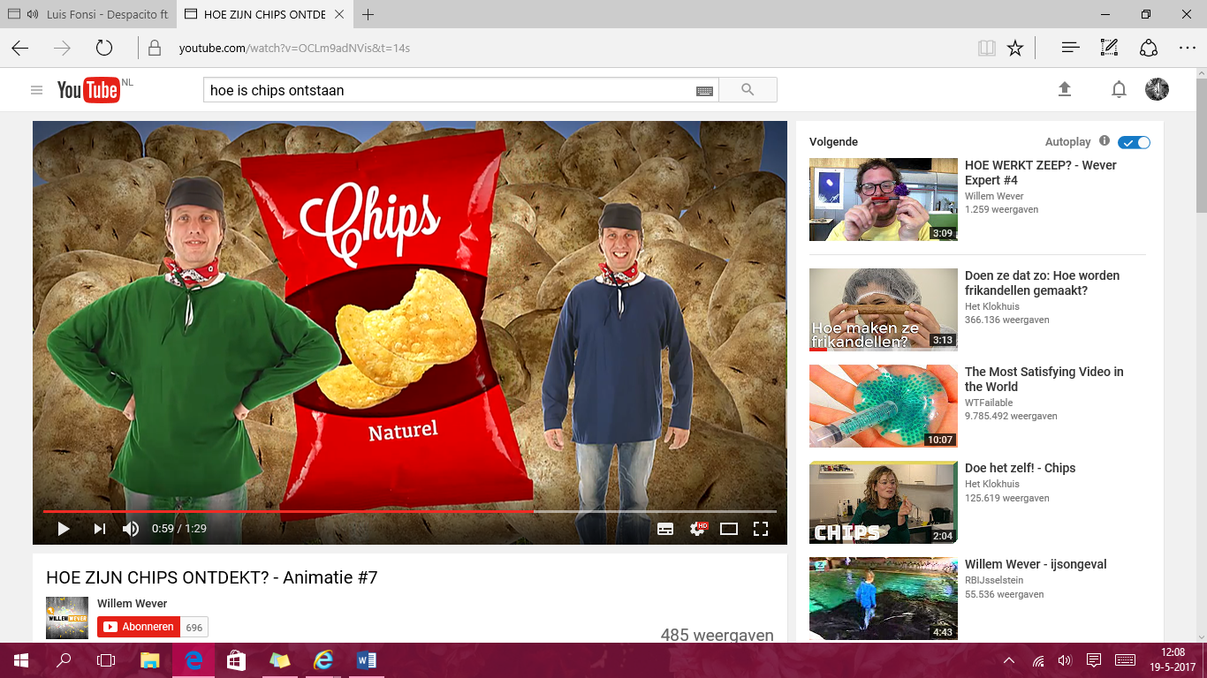


So one of him went to take a look. The potato farmer learned how to make chips
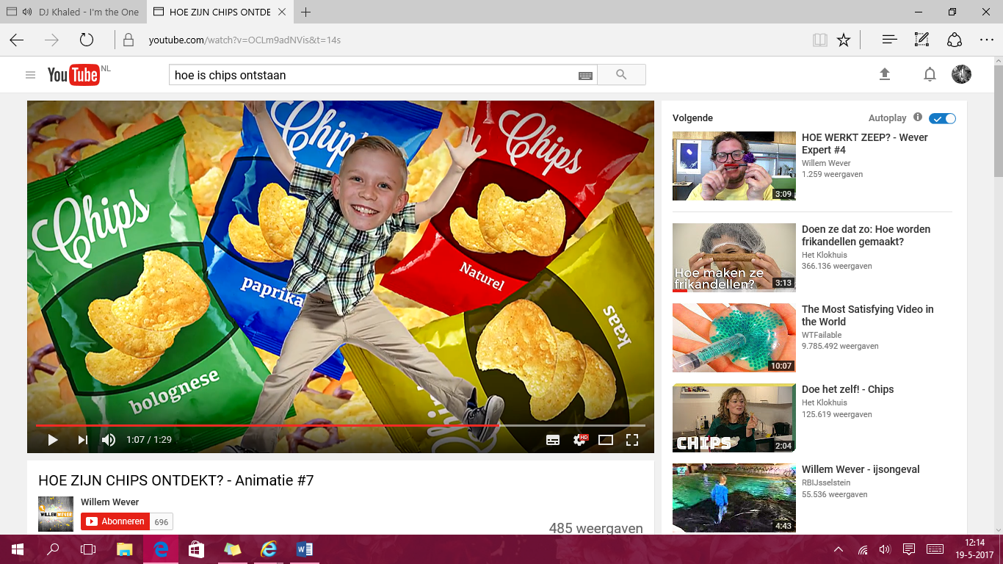
And took the recipe back to the netherlands.
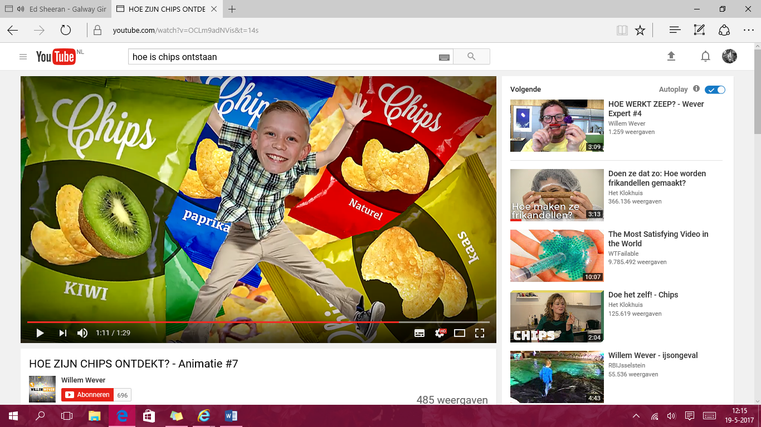

In the meantime, chips around the world are what about for example chips with kiwi flavors
popular and the craziest flavors are devised or chips that taste for squirrels

