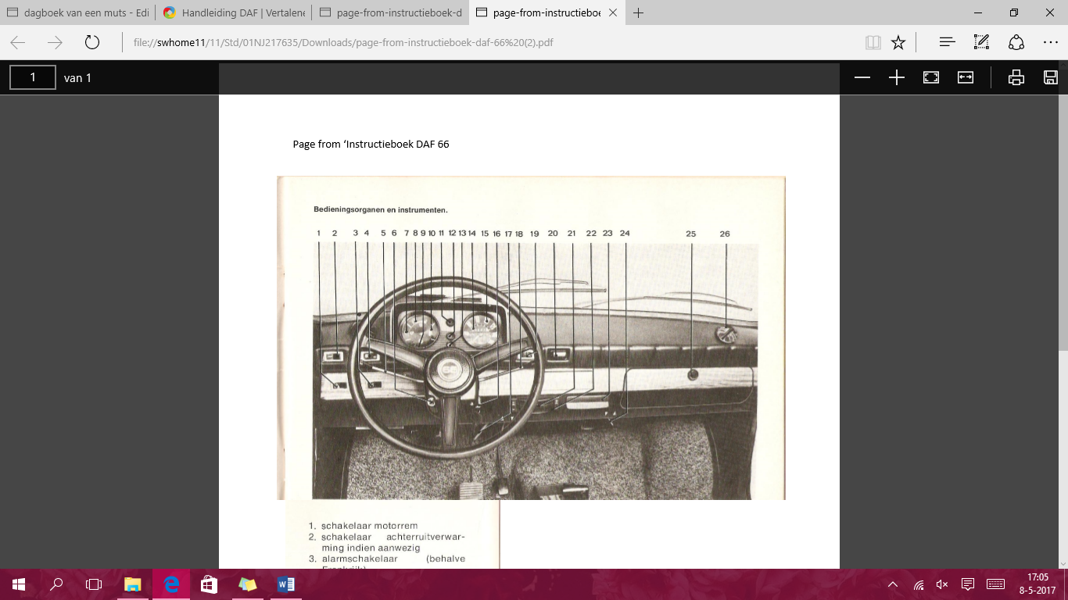

1. Motor brake switch  
2. Switch backwash if present  
3. Alarm switch (except France)  
4. Light switch  
5. Dimmers / warning light signal  
6. Shock button  
7. Oil pressure control (for Norway, Sweden and Switzerland also brake fluid level control)  
8. Gasoline meter  
9. Late check  
10. Cooling water temperature control  
11. Main light control light  
12. Lighting control light  
13. Alarm light warning light  
14. Kilometer counter  
15. Speedometer  
16. Contact lock  
17. Engine cover locking boom  
18. Directional / Claxon switch  
19. Wiper switch  
20. Spray sprayer operation   
21. Control knob chute / starter  
22. Hot air control knob  
23. Ashtray  
24. Heat heater distribution box  
25. Glove box  
26. Control valve cold air