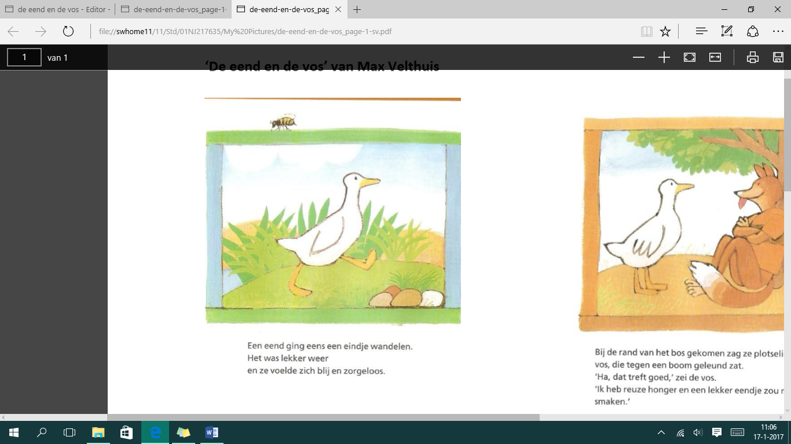
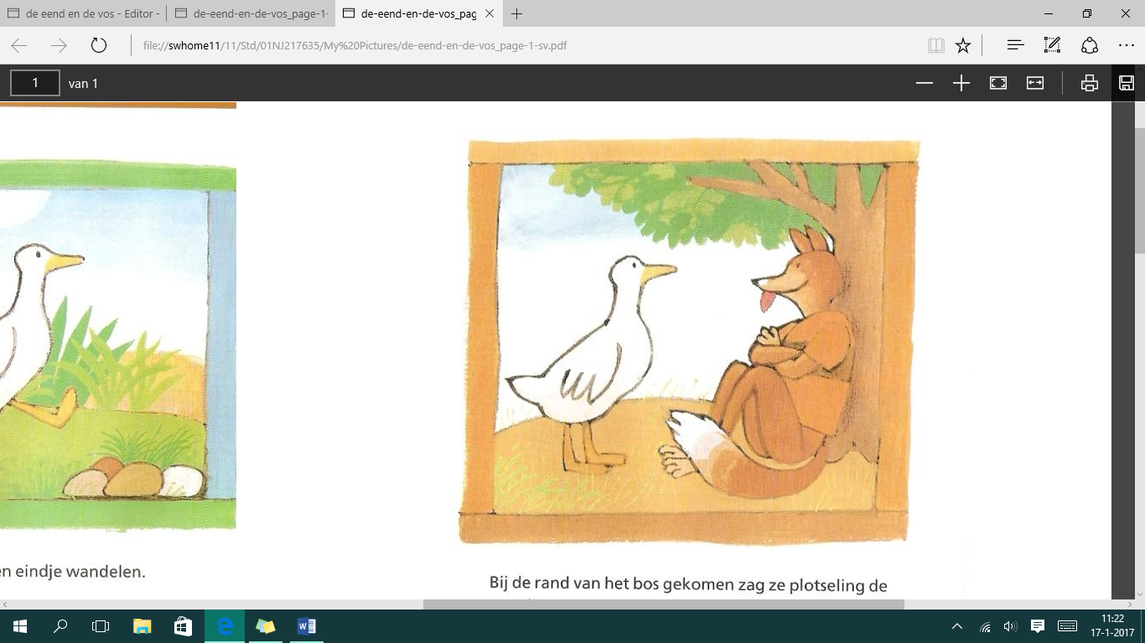
‘ The duck and the fox’ from Max Veldhuis

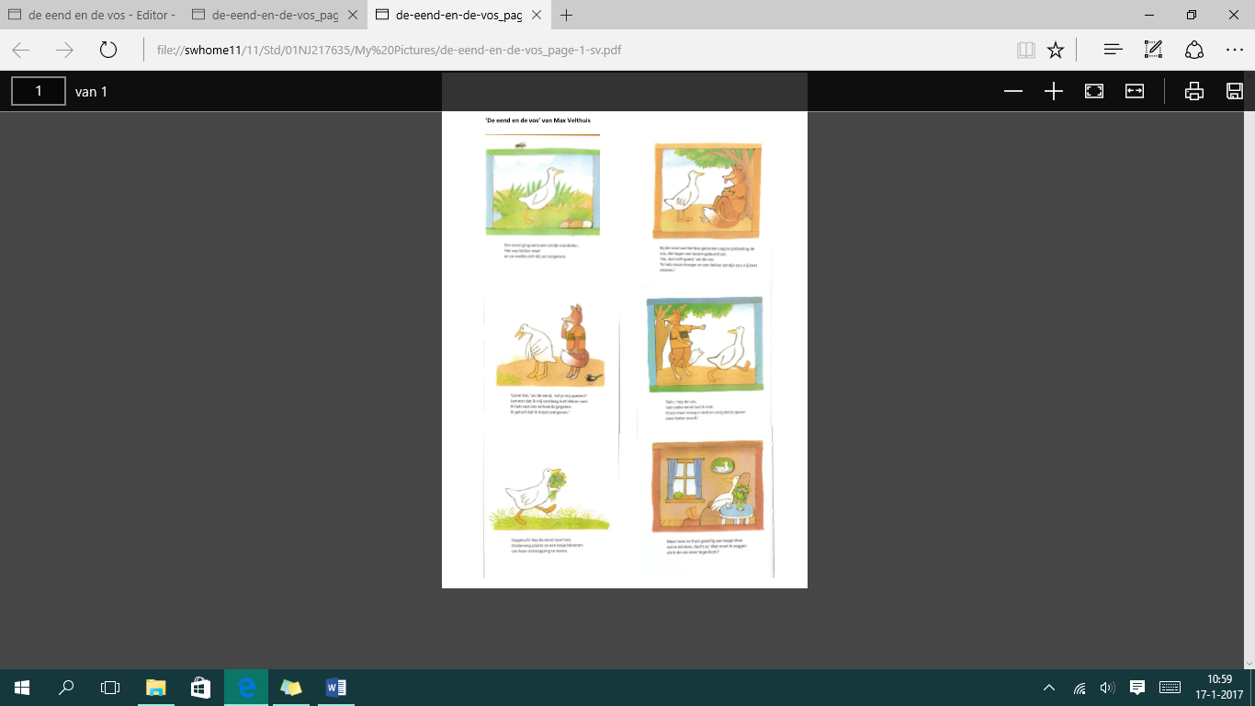

a duck went for a little walk. Ariverd at the edge of the woods
It was nice weather Suddenly she saw a fox, that was
And she felt happy and carefree leaning against the tree.
‘ ha thats nice’ said the fox
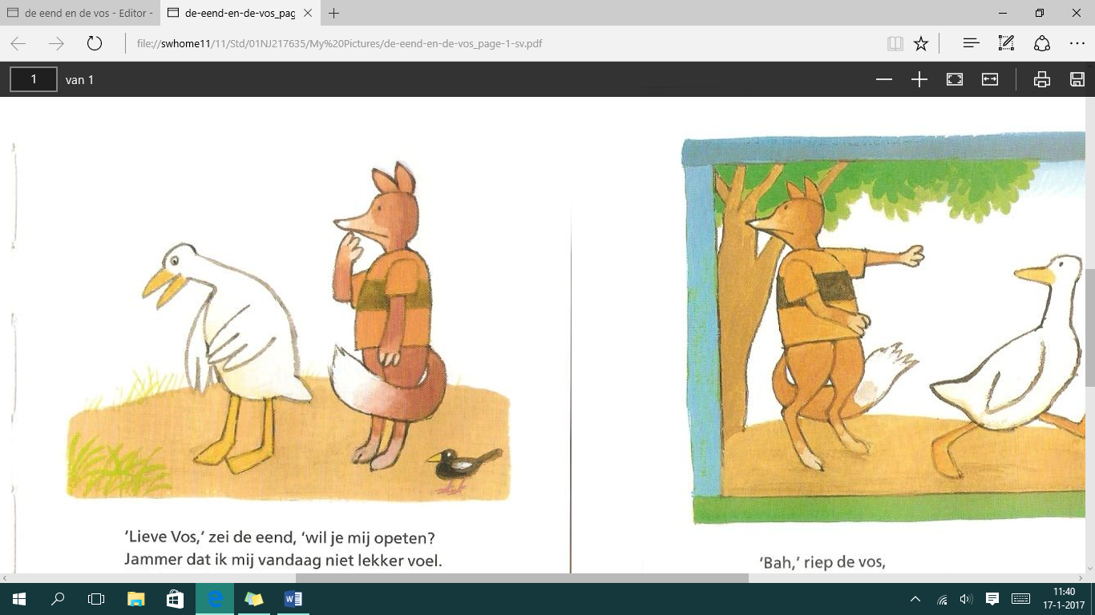
I’’m realy hungry and a tasty little
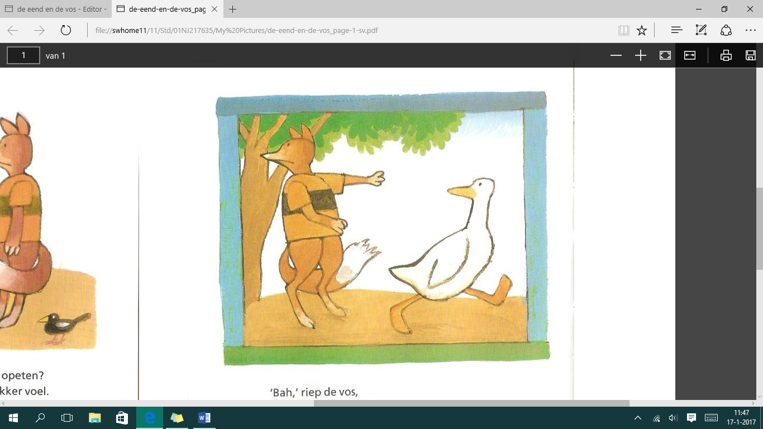
duck would taste realy nice’

‘ Dear fox’ said the duck,
Do you want to eat me?
Too bad that i feel a little sick today. ‘ Ew ‘ screamed the fox,
I must have ate somthing wrong, ‘ I don’t eat a sick duck
I think i need to puke crowl early into bad and make sure
You get better soon

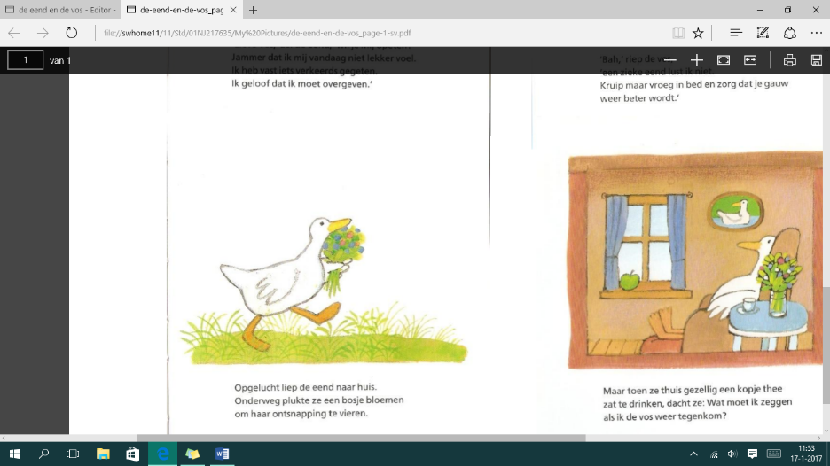
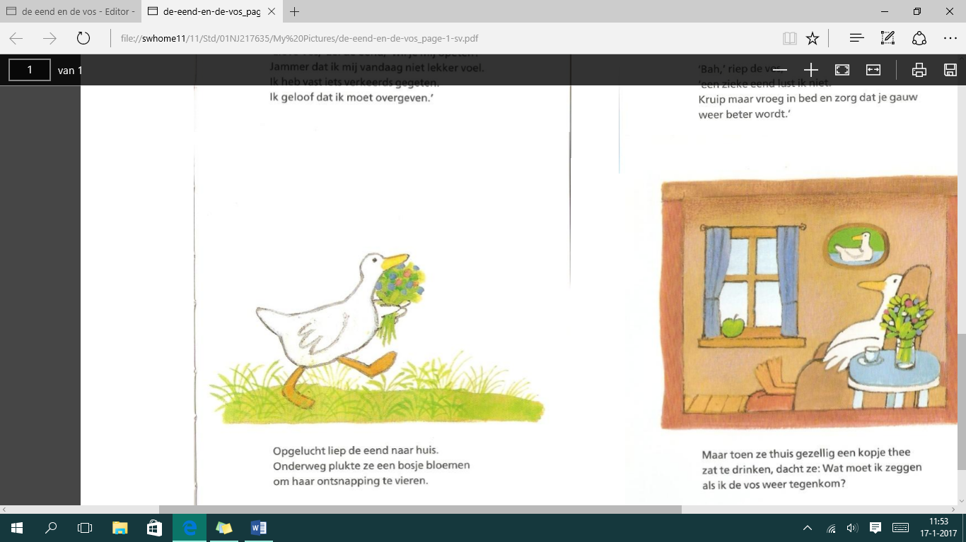

Relieved walked the duck back home. When she was drinking a cup of thee
On her way she picked a bouquet of at home, she started thinking: what
Flowers, to celebrate her escape. Do i have to say if i mate the fox
Again.

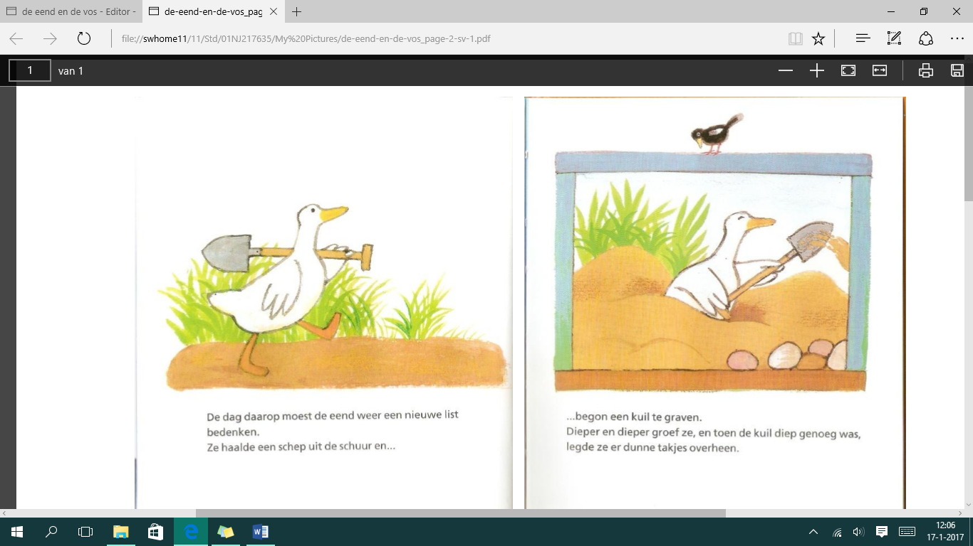
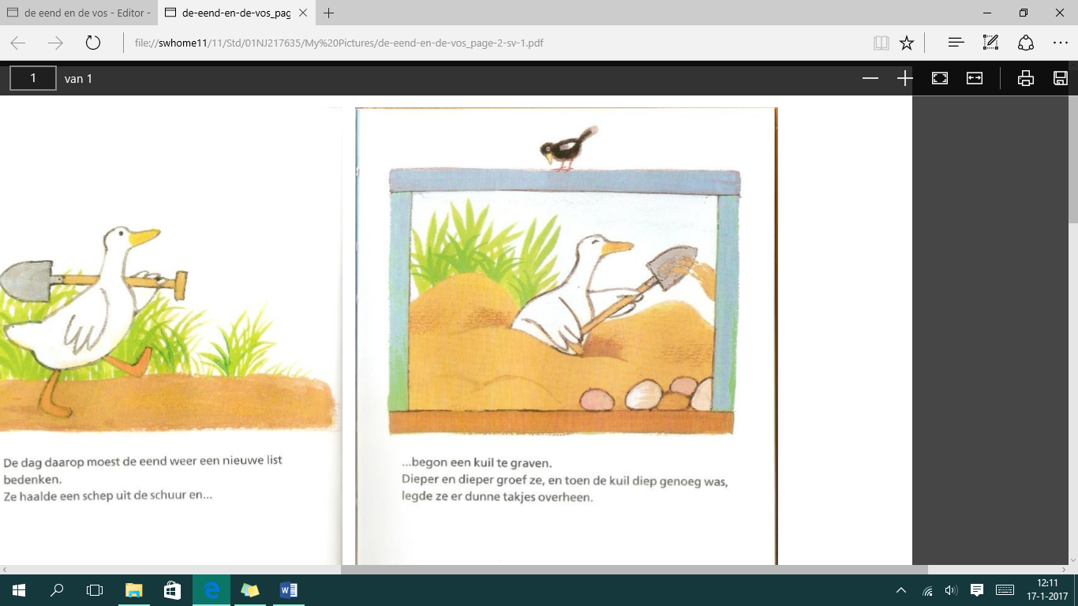

The next day the duck had to make … and starded to dig a hole.
A new list. She grabbed a shovel she was diggin deeper and deeper, and when
Out of the barn. The hole was deep enough, she layed thin
Sprigs over the hole.

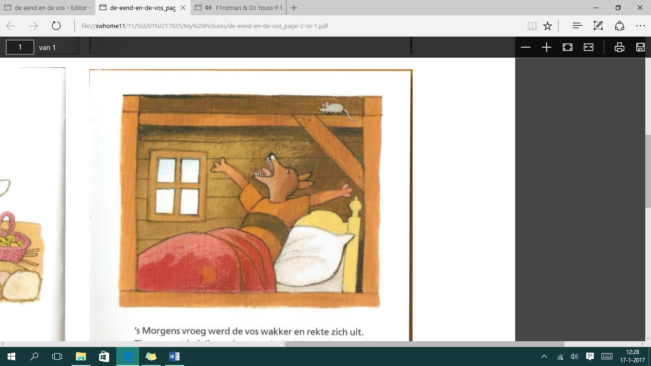
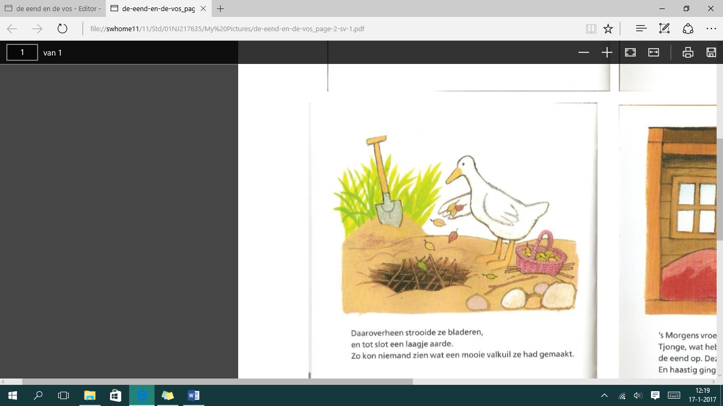

Over that she sprinkled leaves, the fox wake up early in the morning
And finaly a layer of dirt. And he streched out, jeez i’m realy hungry
So no one could see the beatyfull today i will eat the duck. This time she will
Pitpall She mate. Not escape. and hastily he went on his way
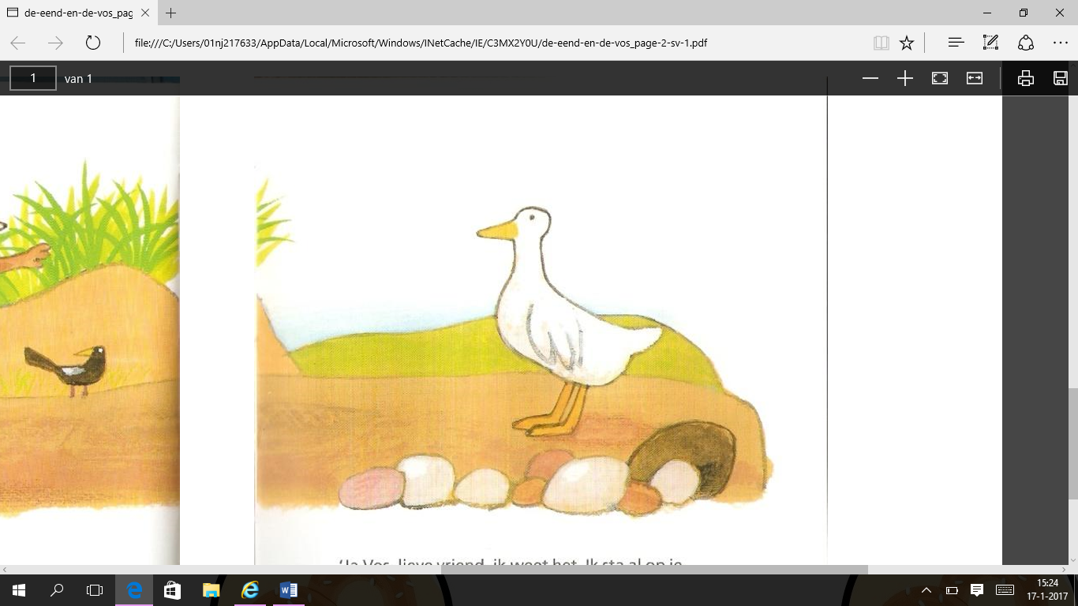
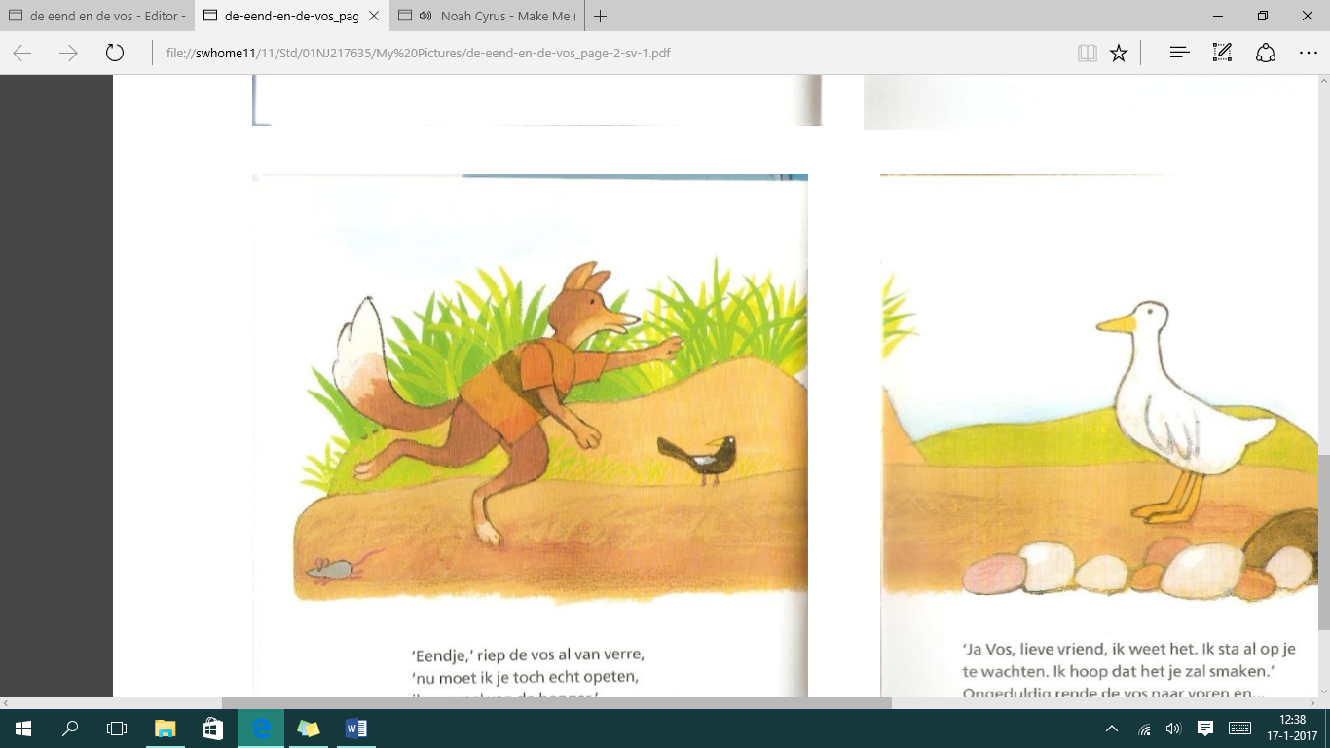

‘ ducky’ shouted the fox from far away. ‘ yes fox, my dear friend i know. I’m already
‘i realy need to eat you now. Whating for you, i hope it will taste good.
‘i’m hungry like a wolve’ impatient the fox ran vorward and…

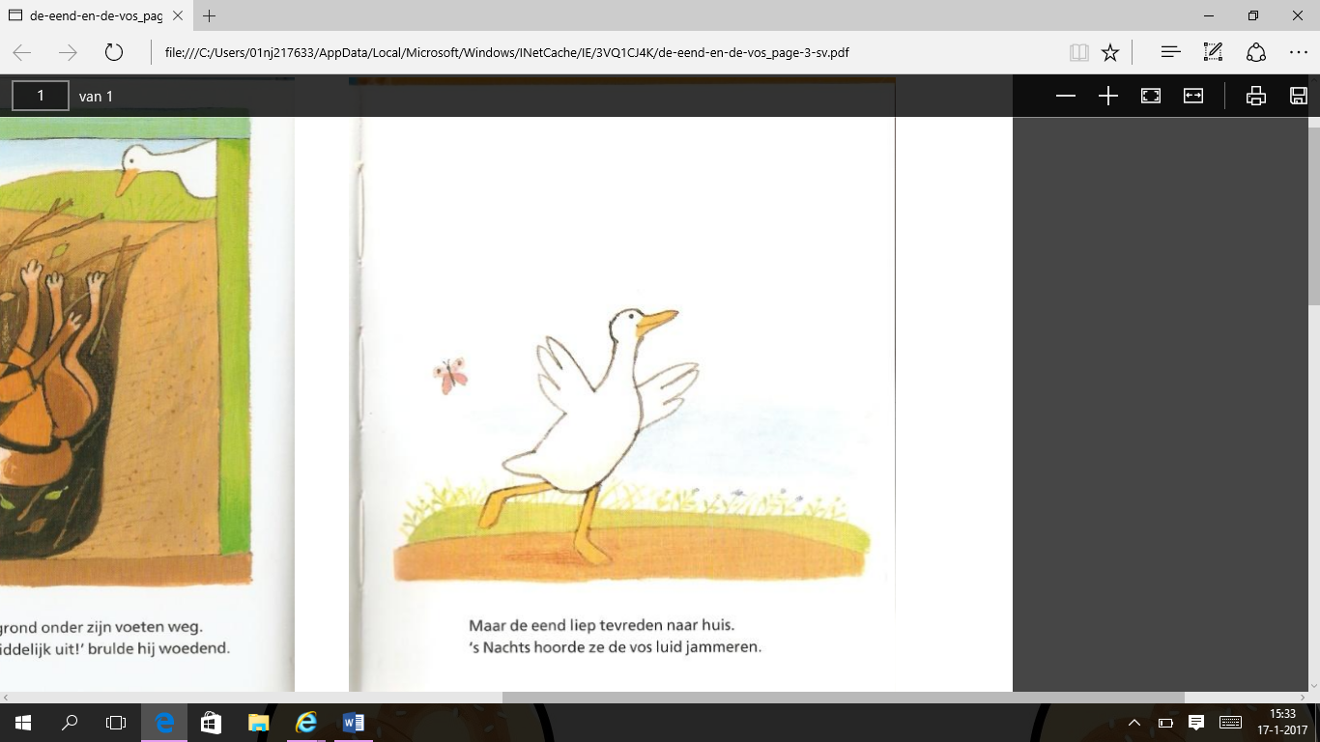
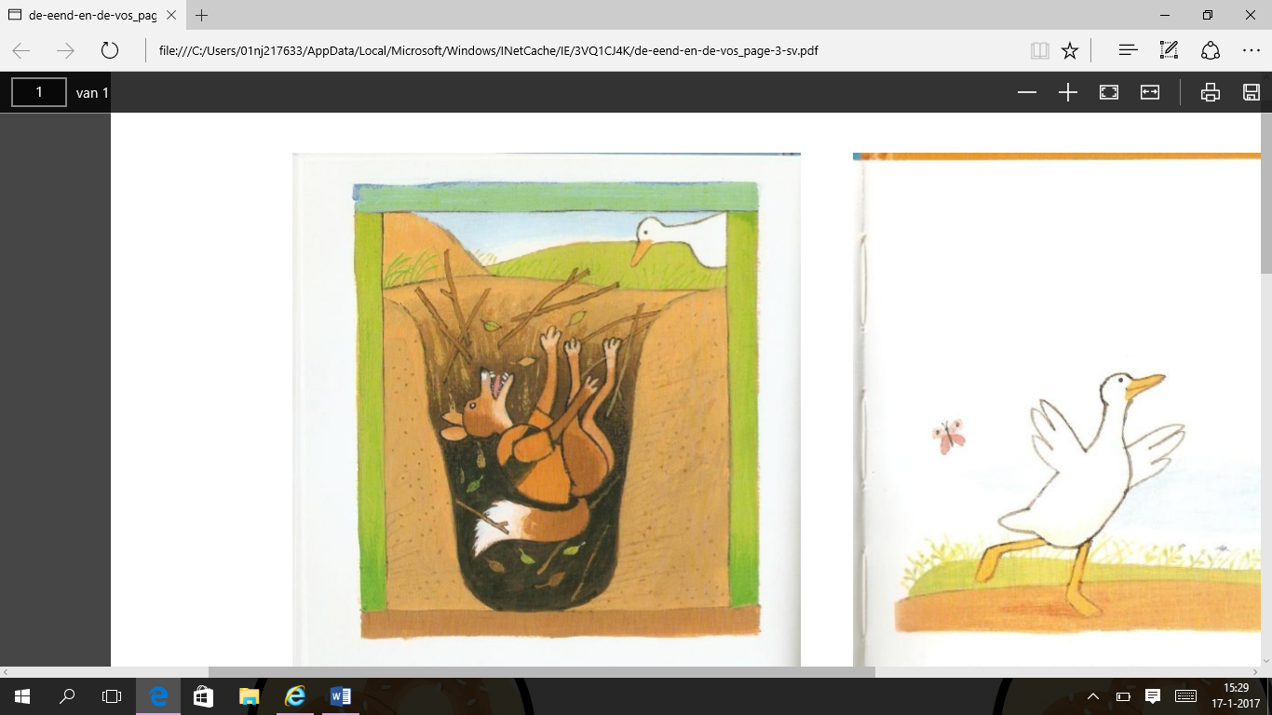

… suddenly the ground under his but the duck walked happy back home.
Feet sank away. At night she could hear the fox
‘help get me out of this instantly!’ loud moaning.
Feet sank away.
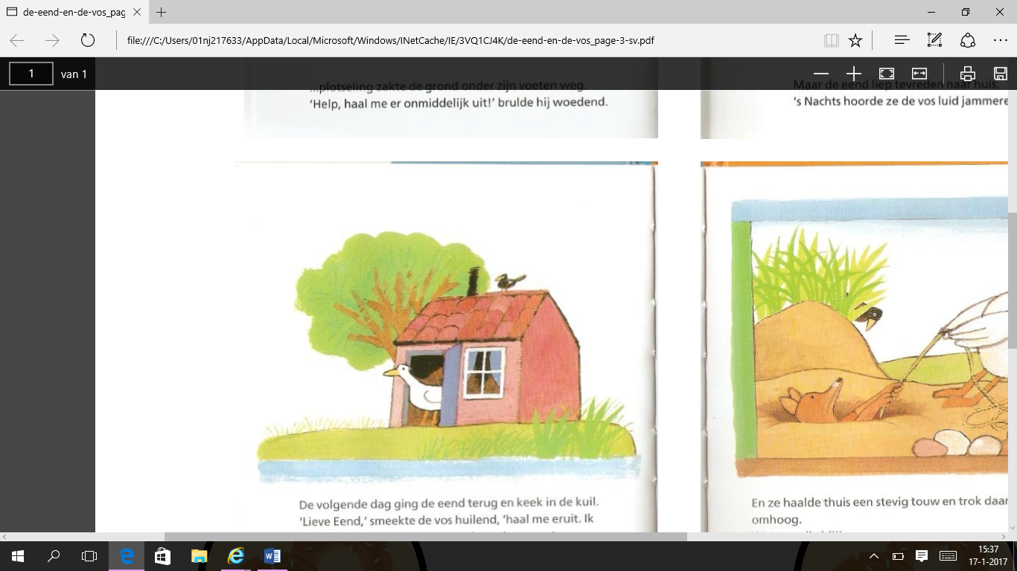
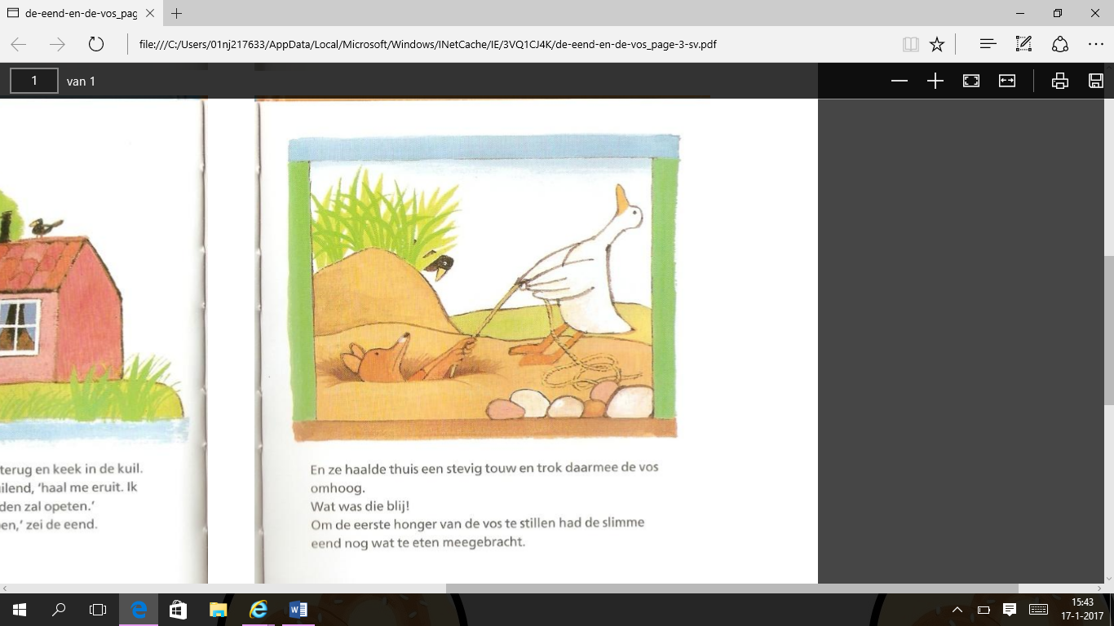

The next day the duck walked to the hole at home she picked up a firm rope and
To take a look, ‘sweet duck’ pulled the fox up, he was very happy!
The fox begged crying ‘get me out of to still the first hunger from the fox
Here’ i promise that i will never eat brought the smart duck some food
Ducks again. ‘if you promise that with her.
I will help you’ said the duck.

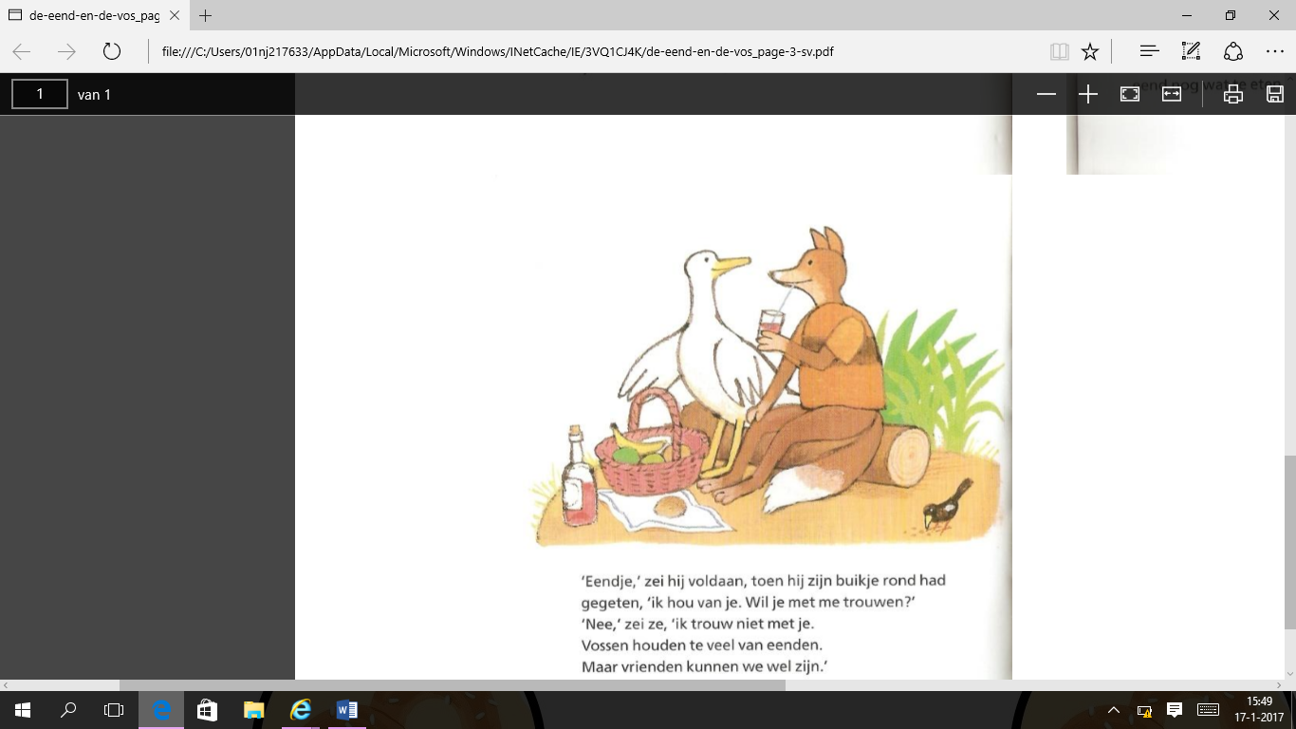

‘ducky’ said the fox satisfied,
When he ate his belly around,
‘do you want to marry me?’
‘No,’ she said ‘i won’t
Marry you. Foxes like
Ducks way too much.
But we can be friends.

